

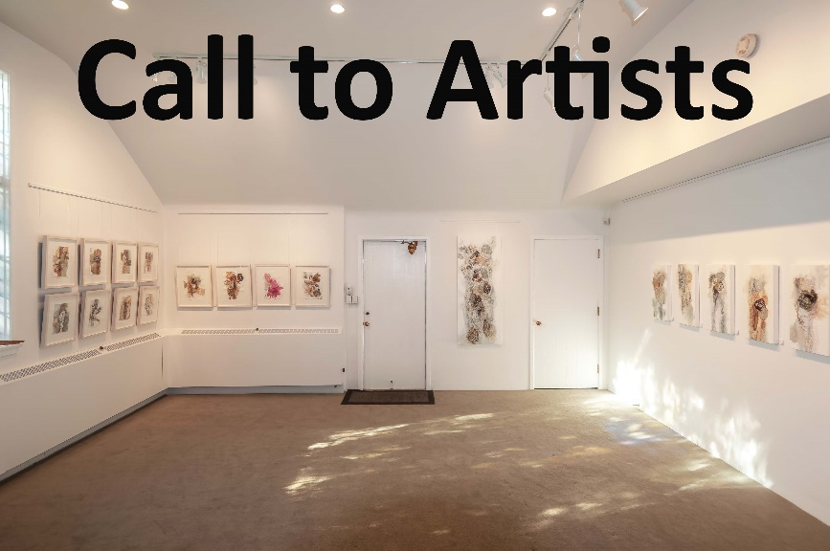ccc

The Chapel Gallery is a multifunctional, not for proﬁt, volunteer run Gallery that presents six exhibitions a year. We are currently accepting proposals for our **Fall/Spring 2020/2021 program**.

We invite artists to respond to the concepts around our “Seasonal Themes” We ask that artists interpret a chosen theme using their own unique voice. We do not require works to reﬂect a religious orientation.

See our Website for information on Themes and Submission Guidelines. [**www.stmatthiasvictoria.ca/chapelgallery**](http://www.stmatthiasvictoria.ca/chapelgallery)

- Accept Painting, Drawing, photography, mixed media, sculpture and ﬁbre art. - Open to artists on Vancouver Island & the Gulf Islands. - Solo or group exhibitions as well as curatorial proposals welcomed. - Shows run for 3 weeks, 3 days a week, with opening reception. - No fee is required, only commission of 15% on sales. - Proposals will be adjudicated by a jury of four.

Please send complete proposals using format on website to: [**chapelgallery600@gmail.com**](mailto:chapelgallery600@gmail.com)

**Call close December 30th**